Unit 6.4 : Air Pressure
Topic : Magic water glass trick
Worksheet 1

Name: ______________
Class: __________( )
Date: ______________

Task 1: Explain why does water stop flowing into an empty bottle?

Materials: glass bottle, funnel, stopper and beaker of water

Procedure
- Set up a glass bottle with one-hole stopper and a funnel as shown.
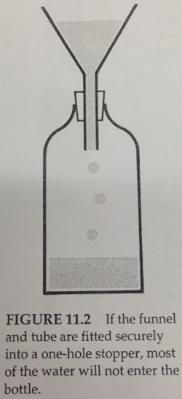
- Predict and explain what will happen if we pour water into the empty bottle.

- Then, pour water into the bottle. Ask students to write and explain their observations.
Only few drops of water can go into the bottle. It cannot flow into the bottle smoothly. Teacher might ask students to explain this with the aid of drawings.

- Someone suggests that some substance fills up the bottle so that water cannot flow into the bottle. Do you agree? Explain your answer.
Yes, the ‘empty’ bottle is filled up with air. When we place a funnel with water on the top, the air inside the bottle is not able to escape. Thus air pressure is formed inside the bottle and it exerts force to block the water flow into the bottle.

- Why can drops of water enter the bottle if the bottle is filled up with air?
The air can be compressed and some water can go into the bottle to fill up the space.

- What will happen if you lift up the stopper? Explain your answer.

When we lift up the stopper, the air can escape from the bottle. The air pressure inside the bottle decreases and the force blocking the water flow disappears. The water in the funnel can flow into the bottle smoothly.

